Instructions for Viewing and Capturing OS-6 Data Output
Mac OS X
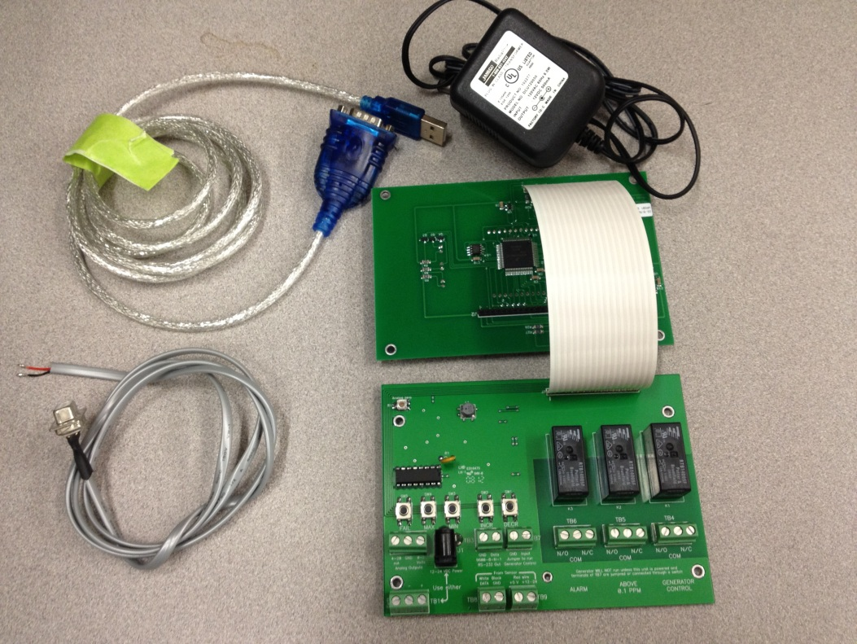
Power Supply
OS-6 board
OS-6 data cable
USB to Serial cable
Figure 1. Components

Install Software:
- Connect USB drive to Mac OS X computer and open EcoSensors folder.
- Install the 3rd-party drivers for the USB-to-Serial cable on the Mac OS X computer by clicking the file: PL2303_1.4.0.dmg.
- Install the 3rd-party data logging software on the Mac OS X computer by clicking the file: CoolTerm.dmg.
Hardware Setup:
- Connect power to the OS-6.
- Connect the data cable to the OS-6 by attaching the ground wire (black) and data wire (red) to the TB3 connector on the OS-6, as shown in Figure 2.
- Connect data cable to the USB-to-Serial Cable.
- Connect USB end of the USB-to-Serial Cable to the Mac OS X computer.

Run Software:
- Open CoolTerm.
- On the top menu, press “Connect”, as shown in Figure 3.
- Data will be displayed in 3 columns, each separated by a comma.
  - First column is ozone reading (in ppb)
  - Second column is temperature (in °C)
  - Third column is Relative Humidity (in %) (example shown in figure 4).
- To log data while CoolTerm is running (Figure 5),
  - Click on “Connection” at the top menu
  - Go to “Capture to Textfile”
  - Press “Start”
  - Define where the file should be stored on the computer and press “Save”
  - CoolTerm will now automatically log all data.
- To stop logging data,
  - Click on “Connection” at the top menu
  - Go to “Capture to Textfile”
  - Press “Stop”

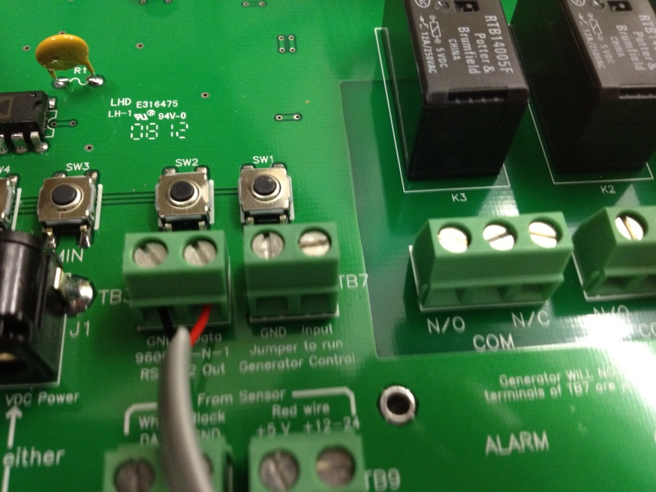
Figure 2. Data and ground wires connected to TB3 on OS-6
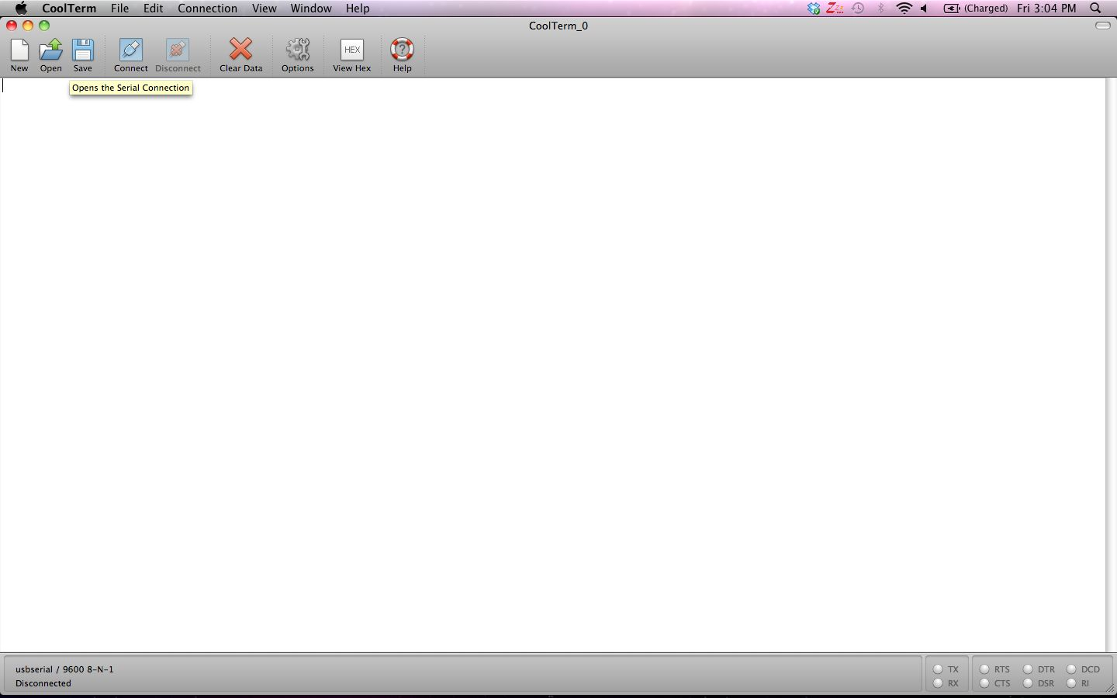
Press ‘Connect’
Figure 3. Connect CoolTerm to Instrument

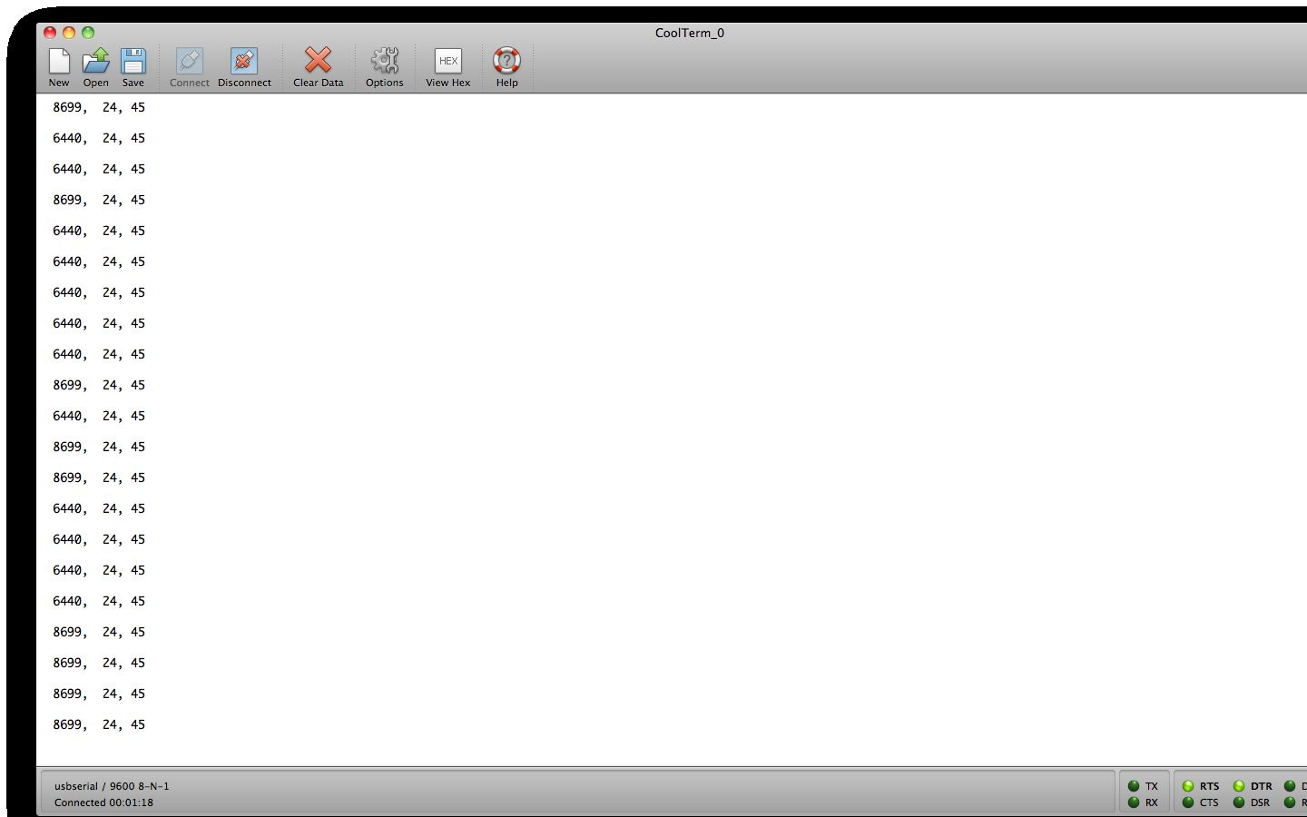
Figure 4. Example of instrument output: ozone (PPB), T(°C), RH(%)
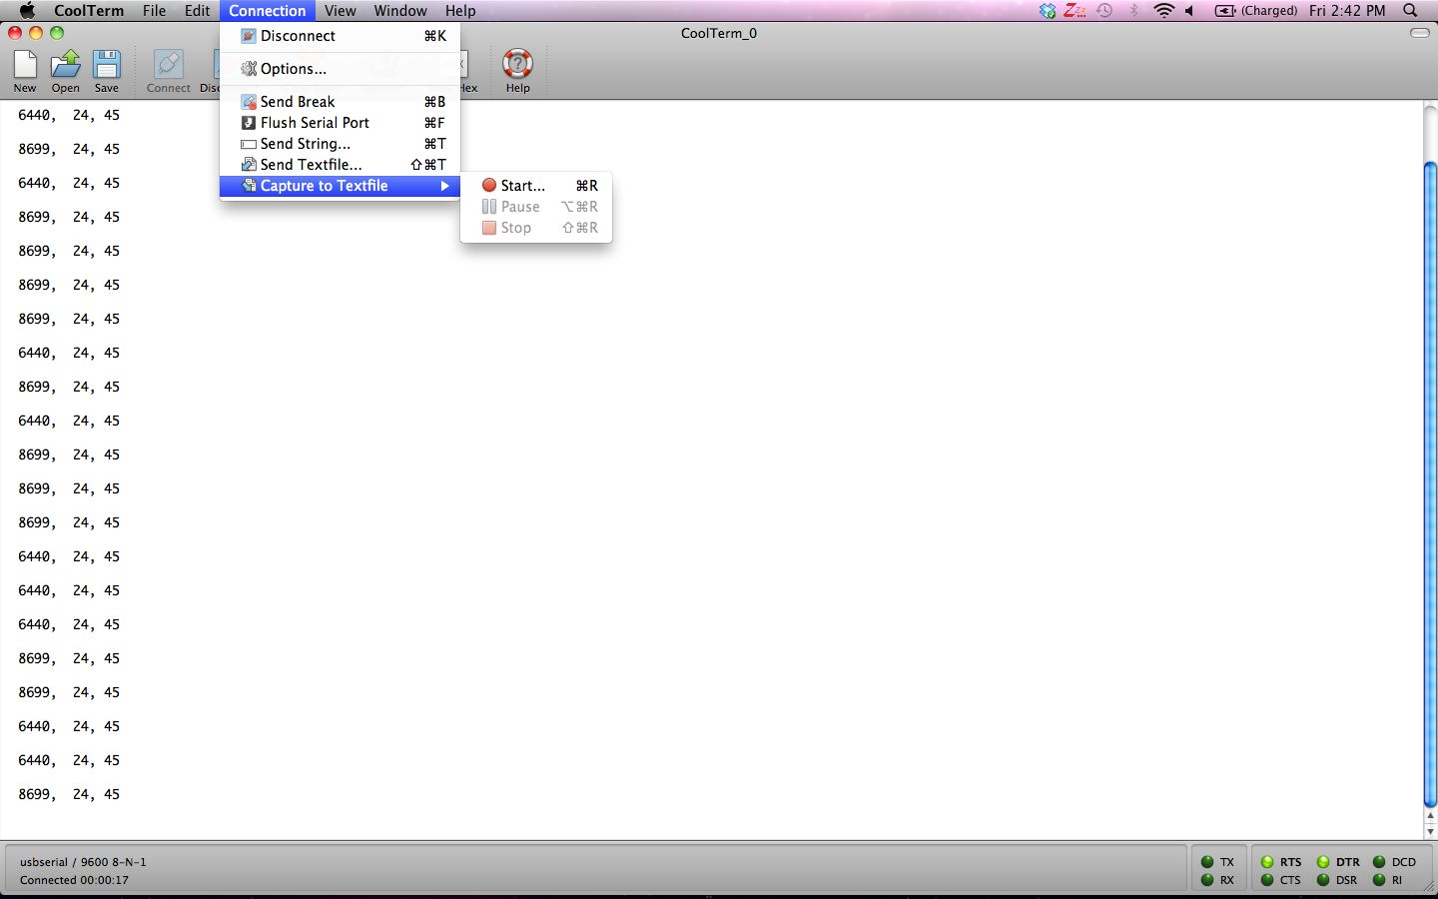
Figure 5. Start logging data

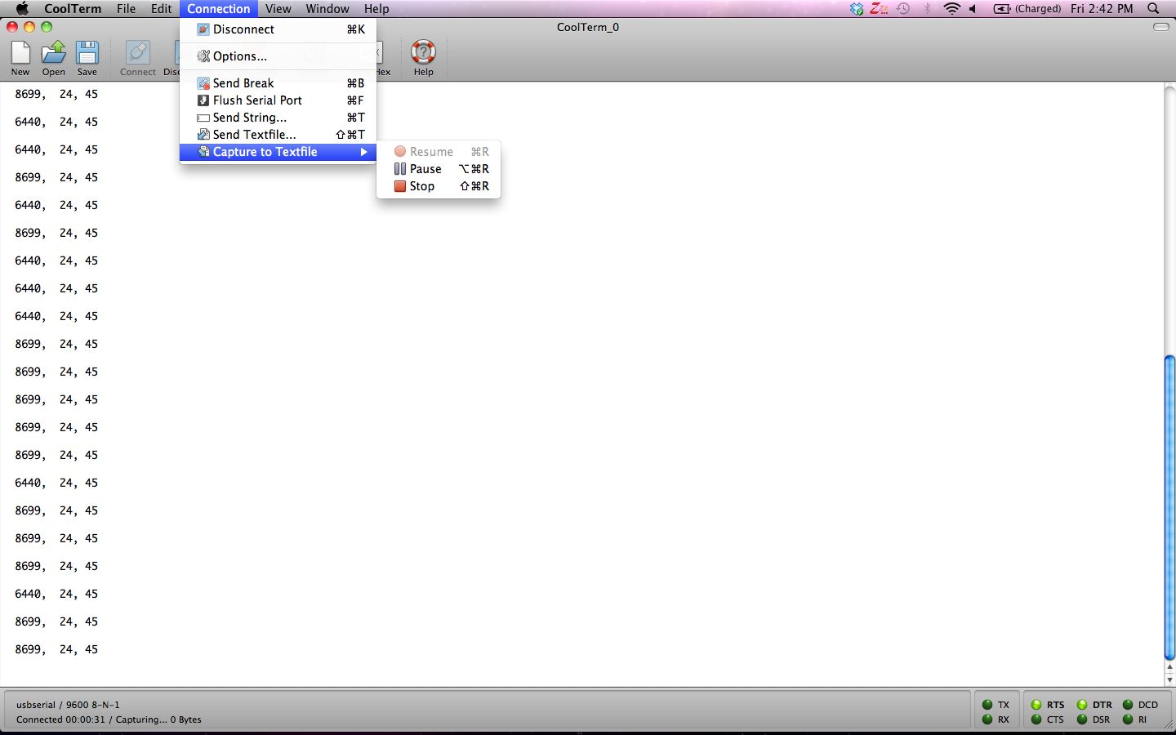
Figure 6. Stop logging data

